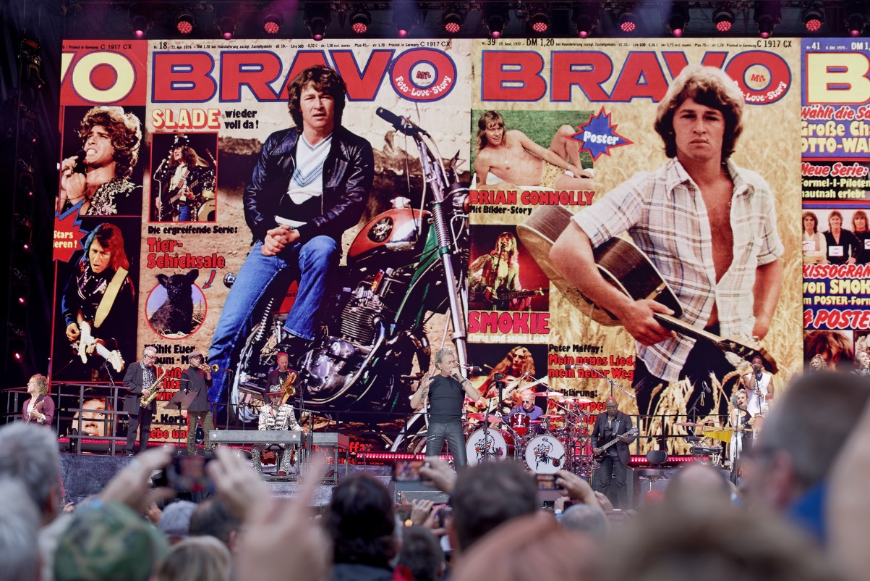

Peter Maffay Farewell Tour
Filling Germany’s biggest open-air arenas with the 2024 “We love Rock’n’Roll” tour

Wedemark, October 2024 – With the “We love Rock’n’Roll” Farewell Tour, Peter Maffay and his band filled Germany’s biggest open-air arenas in the summer of 2024. Digital and analogue Sennheiser wireless systems ensured excellent sound during the performances. In addition to Sennheiser Digital 6000 systems and other proven wireless solutions, the new Sennheiser EW-DX series was also used for the shows, including the brand-new EW-DX EM 4 DANTE four-channel receiver.

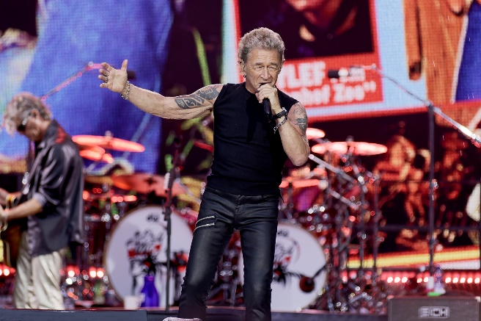 | Peter Maffay on his “We love Rock’n’Roll” Farewell Tour

Premiere for Sennheiser EW-DX
Celebrating their premiere on a Peter Maffay tour were two EW-DX EM 4 DANTE four-channel receivers, which were used with EW-DX SK 3-PIN bodypack transmitters on the woodwind and brass, for Pascal Kravetz’s accordion and guitars, and for show guests such as Wolfgang Niedecken of BAP.

The wireless rack with the EW-DX EM 4 DANTE four-channel receivers | 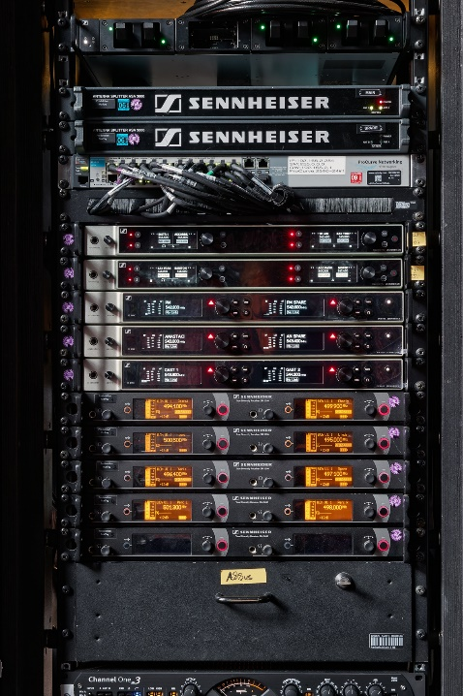

Previous Peter Maffay tours used only one EM 6000 two-channel receiver (Maffay’s vocals & spare), but the Farewell Tour concerts were equipped with three EM 6000 receivers, providing US star Anastacia (vocals & spare) and a variety of guest stars (Johannes Oerding, Joy Denalane, Rea Garvey, Wolfgang Niedecken, Bülent Ceylan, Hartmut Engler) with excellent digital audio. While Peter Maffay and the backing vocalists used cardioid Sennheiser MM 435 microphone modules on their handheld transmitters, Anastacia and other guests were equipped with super-cardioid MM 445 capsules. The battery packs for their SKM 6000 handheld transmitters were recharged in the network-compatible L 6000 charging station.

Sennheiser’s famously reliable technology could be found everywhere on stage. For example, the performers received their monitor signals wirelessly via 14 Sennheiser SR 2050 IEM stereo transmitters. The backline sound engineers also had eight channels at their disposal, which they used to listen to their own performer’s mix. They were also able to communicate with each other on these channels without disturbing the performers. Two A 5000-CP passive antennas with circular polarisation were used as antennas for the IEM systems, and these were installed together with an oversized dummy carrot that stage designer Michael Haufe had created some years ago for a Tabaluga tour. At that time, the “carrot microphone” concealed a Sennheiser SKM 2000 handheld transmitter.

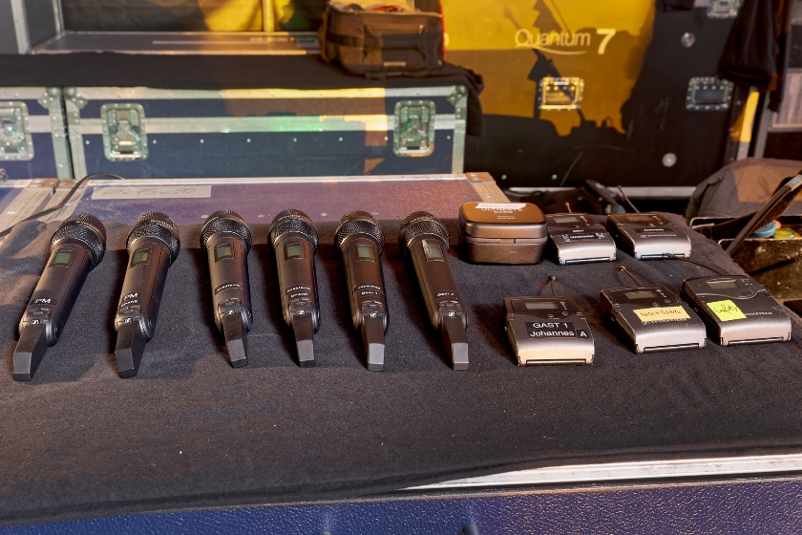 | SKM 6000 handheld transmitters ready to go

Guitarists Peter Keller and Pascal Kravetz and bass player Ken Taylor used wireless channels from the evolution wireless series. Multi-instrumentalist Charlie Klauser even wore as many as three beltpacks: an in-ear receiver as well as two SK 500 transmitters, which transmitted the percussion signals from Sennheiser MKE 2 clip-on microphones attached to her hands. The sound of the violin that Charlie Klauser played was also transmitted via an ew 500 wireless system.

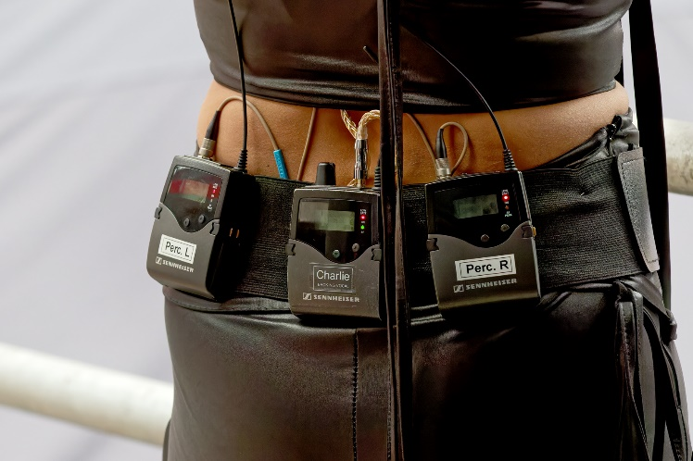 | Multi-instrumentalist Charlie Klauser wore as many as three beltpacks: an in-ear receiver as well as two SK 500 transmitters, which transmitted the percussion signals from Sennheiser MKE 2 clip-on microphones attached to her hands

Sennheiser MM 435 microphone capsule: perfect for vocals
The MM 435 dynamic high-end microphone capsule from Sennheiser was highly praised by all sides on the tour, including FOH mixer Timo Hollmann: “I suggested using this capsule for the vocals long before the start of the Farewell Tour,” the experienced sound engineer said.
“I put the MM 435 through its paces with numerous newcomer bands in various clubs and I was really impressed right from the start - and I still am to this day! It’s a dynamic capsule that is robust enough for touring use but still sounds like a condenser capsule. I like the really tight low mids, which can sometimes be pretty annoying with other capsules and make you want to reach for the EQ to get rid of them. But with the MM 435, I don’t have to intervene in this frequency range and I actually only use gain and low cut in the relevant channel.”

FOH mixer Timo Hollmann | 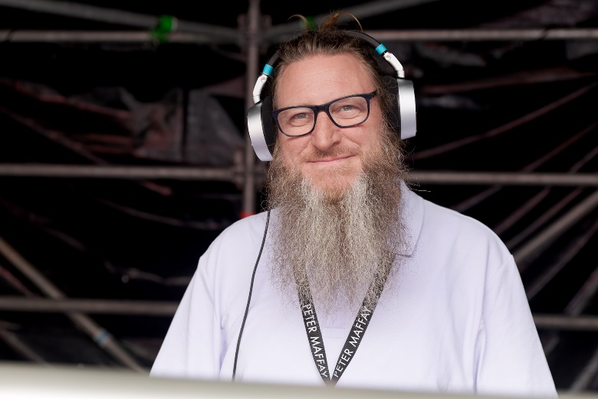

The MM 435 dynamic microphone capsule has a cardioid pick-up pattern and is characterised by a detailed sound and a high degree of transparency. Vocalists are really able to assert themselves with this microphone module, which is compatible with many hand-held transmitters thanks to Sennheiser’s standard capsule interface. Even in loud environments the vocals can be clearly heard and have superb presence. The dynamic range is greater than 146 dBA, and the maximum sound pressure level is impressively high at 163 dB.

For communication purposes on the Farewell Tour, Hollmann used a modified Sennheiser e 835 S microphone. Its on-off switch was replaced by a non-latching version, enabling it to be used according to the push-to-talk (PTT) principle. During the show, Hollmann could often be seen wearing closed Neumann NDH 20 headphones. “I use Neumann headphones in my studio, and the NDH 20 works really well at the FOH console, especially because it has an impedance of 150 ohms and lets me listen at high volumes if I need to,” he said. “During rehearsals, I set up the entire mix using the NDH 20 on my digital console. I’ve already recommended these headphones to lots of colleagues simply because they work fantastically well at live shows.”

Neumann MCM for the Harley
A Neumann Miniature Clip Mic system, operated with a Sennheiser EW-DX SK 3-PIN bodypack transmitter, could be found at a somewhat unusual location on the Farewell Tour. Peter Maffay couldn’t resist the opportunity to start the show by riding onto the stage in full leather gear on a black Harley-Davidson. And to make the best of the acoustics of this legendary motorbike, wireless specialist Florian Keinert had attached an MCM KK 14 miniature condenser capsule above the exhaust pipe.

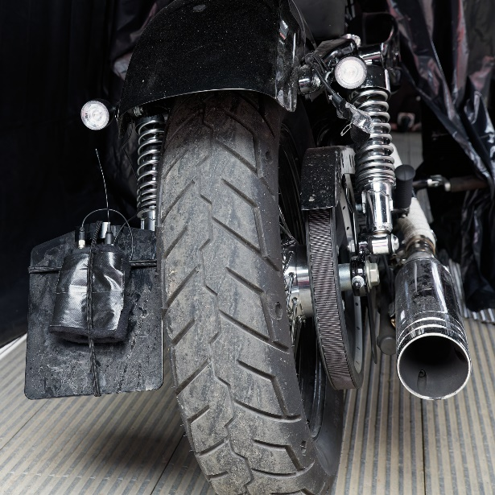 | The miked-up Harley

To protect it from the rain, the capsule was covered at the top by a piece of plastic foil, which Keinert had fixed with black gaffer tape. The SK transmitter was placed in a protective case and strong rubber bands were used to attach it to the number plate holder. Of course, there were also more conventional applications for the Neumann Miniature Clip Mic system: KK 14 capsules were used to mike the woodwind and brass instruments and an accordion.

Wireless specialist Florian Keinert | 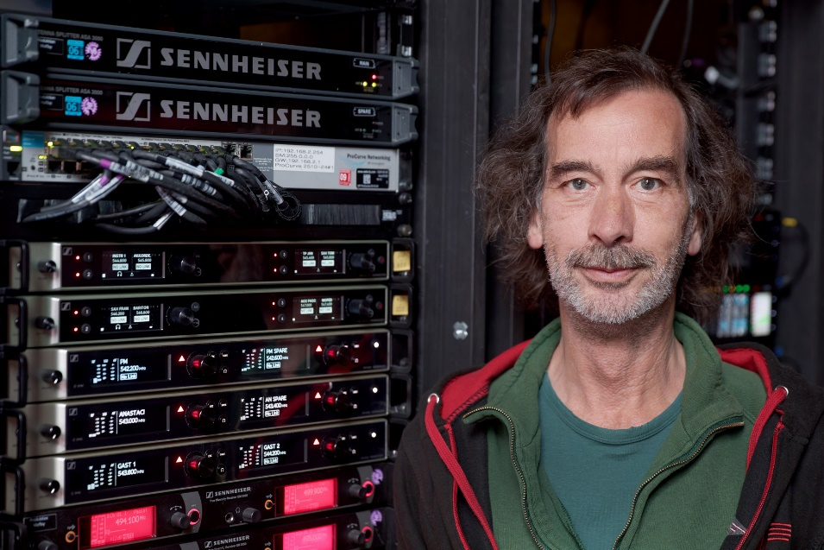

Frequency management with Sennheiser WSM software
Keinert used WiNRADiO hardware and software for the scans of the RF environment. In addition, the Sennheiser Wireless Systems Manager was employed for continuous real-time control and monitoring of all relevant parameters.

“The digital Sennheiser wireless systems work without intermodulation, which is a great advantage because I can accommodate them practically anywhere in a free area of the frequency spectrum,” said Keinert. “I use the equidistant grid – I can fit all the digital channels into the space of one television channel. The analogue in-ear wireless channels operate in the GW and BW frequency ranges, and I have arranged the instrument transmitters of the ew wireless channels in the A range and high up in the E range. Overall, I therefore have quite a large working range for the wireless transmission of audio signals, which is why I can easily use an alternative frequency if the situation at the performance venue requires it. I can cover all the artists’ performance areas without problems with two Sennheiser A 2003-UHF and two A 5000-CP antennas.”

Drummer legend relies on Sennheiser
Bertram Engel, also well-known as the drummer for Udo Lindenberg, once again relied on microphones from the Sennheiser portfolio during Peter Maffay’s Farewell Tour. The drummer legend performed with two kick drums: the 28” model was miked with an e 902, an MD 421 and an e 901 condenser boundary plate microphone, while the 24” version only had a Sennheiser e 902 and an e 901.

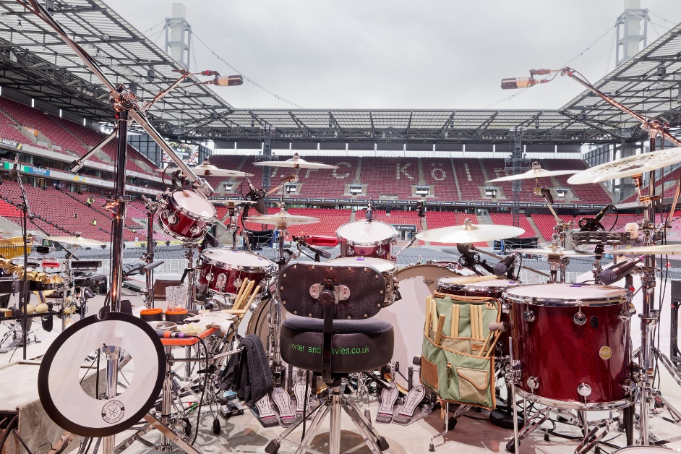 | Bertram Engel’s drum kit

The snare drum was miked from above and below in order to pick up both the attack of the drumhead and the characteristic rustle of the snare carpet in all its nuances. This demanding task was mastered by two dynamic Sennheiser e 905 (cardioid pick-up pattern). The small tom-toms were fitted with Sennheiser e 904, and the floor toms with Sennheiser e 902. For overhead miking, drum specialist Benjamin “Benji” Johl used two high-grade dual-diaphragm MK 8 condenser microphones. Pre-polarised Sennheiser e 914 condenser microphones fitted with foam windshields were used for the two hi-hats.

Sennheiser EW-DX: convincing overall package
The EW-DX EM 4 Dante receivers that were on the farewell tour are the youngest member of the Sennheiser Evolution Wireless Digital family. In addition to providing excellent sound quality, the EW-DX series is characterised by easy operation and a variety of useful features such as “Intelligent Switching Diversity”, which ensures a stable audio connection without audible artefacts.

Latency, which is a factor inherent in all digital systems, is low at 1.9 milliseconds in EW-DX and is not perceivable in practical use. In EW-DX systems, the innovative “Sennheiser Performance Audio Codec” (SePAC) ensures excellent audio transparency from the capsule input to the signal output. The high dynamic range (134 dB) of the transmitters, which are equipped with stacked A/D converters, allows them to be operated without the need to manually set the gain, which can be very helpful when local conditions continually change during long tours.

 | Peter Maffay using an SKM 6000 handheld transmitter fitted with an MM 435 microphone capsule

Thanks to a switching bandwidth of up to 88 MHz, EW-DX can transmit up to 146 channels in Standard Mode (equidistant channel spacing of 600 kHz) and up to 293 channels in Link Density Mode (LD, with 300 kHz spacing) – intermodulation-free with secure AES 256 encryption. The operating time of the rechargeable battery packs is 12 hours, and up to eight hours of operation is possible with standard AA batteries. Depending on the RF environment, the transmitters achieve a range of up to 100 metres, which is sufficient even for large stages.

The EW-DX transmitters feature persistent, “always on” displays on which the most important transmitter information remains visible even when switched off. In addition, the transmitters are equipped with a switchable low-cut filter (18 dB/octave) to reduce noise. All transmitters have charging contacts and a built-in test tone generator.

The EW-DX receivers are equipped with an AutoScan feature that helps in finding the most suitable frequencies. The transmitters are synchronised using “Bluetooth Low Energy” (BLE), which means that, in contrast to common infrared systems, no line of sight is required between the devices. The receivers are fitted with clearly legible OLED displays and have a selective headphone output with volume control, balanced XLR and unbalanced 6.3 analogue outputs, and an RJ-45 socket for Power-over-Ethernet (PoE) operation and integration into control and monitoring networks. The DANTE versions have connections for the Audinate digital audio protocol.

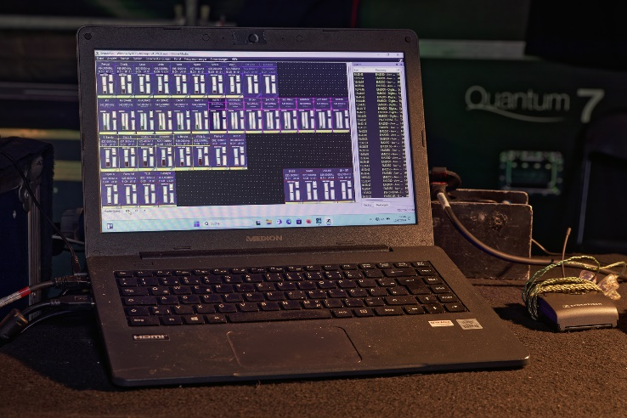 | Wireless Systems Manager at the monitoring console

Several software tools are available for operating and monitoring the transmission channels. The Sennheiser Wireless Systems Manager (WSM) and the Sennheiser Control Cockpit are network-based, although the WSM is an independent software tool while the Control Cockpit is browser-based. Firmware updates for receivers and transmitters are supported. A third software tool is the Sennheiser Smart Assist App for Android und iOS, which is already a familiar feature with the Sennheiser EW-D systems. Smart Assist communicates with the receiver via a Bluetooth connection and is particularly suitable for quickly setting up small systems when neither a computer nor a network is available.

Peter Maffay’s special “Farewell”
“I’m not saying farewell to music. It’s a farewell to touring and the big stages,” said the 74-year-old musician. “I just have the feeling that enough is enough, and I want to spend more time with my family and friends. I neglected them too much in the past.”

Saying farewell to touring – but not to music | 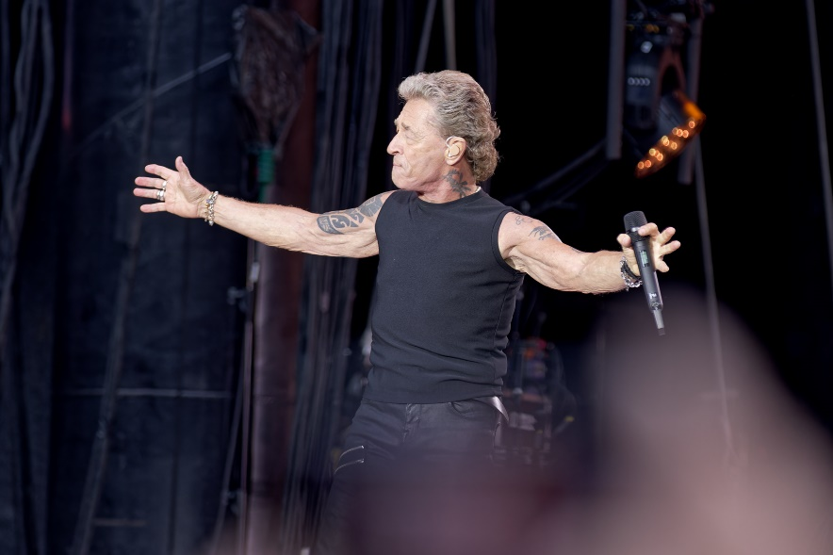

In keeping with this farewell context, the concerts were extremely emotional and not without a certain melancholy, both for Peter Maffay and for his fans who, of course, were absolutely delighted to witness such a comprehensive musical retrospective with all the greatest hits. After all, no less than 20 number one albums in Germany can provide plenty of material for a ‘best-of’ programme. Adding a special touch to the shows was US star Anastacia, whose latest album “Our Songs” covers German hits in English, including a duet with Peter Maffay (“So bist du” – “Just You“).

“The fans love Peter Maffay, but they surely also understand that, after 55 years on stage, he wants to set new priorities in his life,” said Sennheiser Relations Manager Thomas Holz. “With his “We love Rock'n'Roll” Farewell Tour 2024, Peter Maffay had the opportunity to say a personal farewell to around 250,000 concertgoers throughout Germany and he provided them with unforgettable moments through his special selection of songs. I am pleased that Peter Maffay and his band put their trust in Sennheiser solutions for their big farewell tour, as they always have in the past.”

Sennheiser Relations Manager Thomas Holz | 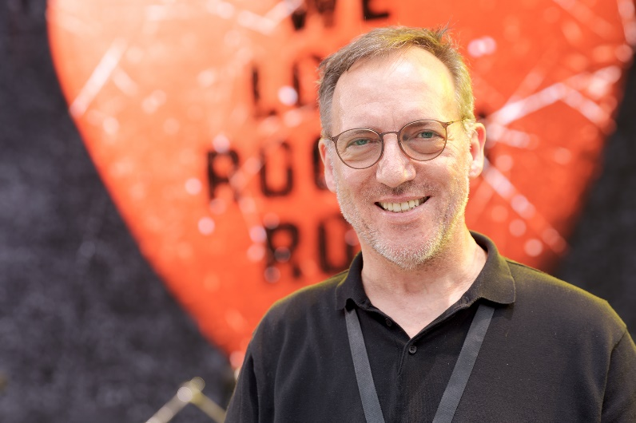

Holz added: “Peter Maffay’s career is an unparalleled success story, and as an artist he is a truly exceptional talent in the German music scene. Whether it is as a rock star, the Tabaluga dragon creator or a social role model: we wish Peter Maffay all the very best for this new phase of his life and express our sincere gratitude for the live partnership with Sennheiser that has lasted for decades.”

(Ends)

The high-resolution images accompanying this media release and further images can be downloaded here.

About the Sennheiser Group
Building the future of audio and creating unique sound experiences for our customers - this is the aspiration that unites the employees of the Sennheiser Group worldwide. The independent family-owned company Sennheiser was founded in 1945. Today, it is managed in the third generation by Dr. Andreas Sennheiser and Daniel Sennheiser, and is one of the leading manufacturers in the field of professional audio technology.
sennheiser.com | neumann.com | dear-reality.com | merging.com

Global Pro Audio Press Contact
Stephanie Schmidt
stephanie.schmidt@sennheiser.com
+49 (5130) 600 – 1275

